**IT INFRASTRUCTURE IMPLEMENTATION**

**PROPOSAL**

**FOR**

### **BATES PAN GULF**

**(Technical & Commercial)**

**Date: 19/11/2016 Sunil Kumar T U**

**Dubai IT infrastructure Architect**

**VCP,CCNA,CCNP,MCSE,ITIL@V3**

**TABLE OF CONTENTS**

**EXECUTIVE SUMMARY 3**

**INTRODUCTION TO VIRTUALIZATION 4**

**Overview and Benefits of VMware vSphere 4**

**vCenter Server Components and Services 8**

**PROPOSED SOLUTION 8**

**Server Consolidation 8**

**Software defined storage 9**

**Benefits of Atlantis USX 10**

**Solution Components 11**

**VMware Installation 11**

**ABOUT NETSOLVE SYSTEMS 13**

**BILL OF MATERIAL 14**

# Executive Summary

BPG Group, headquartered in Dubai, is one of the larger integrated communications groups in the MENA region and a part of WPP-the world’s largest MarCom group.

We cater to a wide range of international and regional clients through our extensive network across the region; offices in Abu Dhabi, Beirut, Cairo, Doha, Dubai, Jeddah, Kuwait and Muscat.

Our success comes from the following differentiators:

* **Experience**: We have over 35 years of history in creating and executing solutions for our clients. We have helped build global brands out of local initiatives over the last two decades.
* **Track Record**: We have a documented track record of recognized achievement, which includes working with local/regional market leaders in retail, government initiatives, financial services and real estate.

**Integration**: We seamlessly deliver specialist and integrated solutions. Nearly half of our revenue comes through a single-window delivery of integrated programs

# Introduction to Virtualization

Server virtualization has been a game-changing technology for IT, providing efficiencies and capabilities that just aren't possible when constrained within a physical world. And while server [virtualization](http://www.infoworld.com/d/virtualization) has continued to mature and advance itself, some virtualized organizations are still not taking full advantage of the offering.

Server virtualization on the x86 platform has been around now for more than a decade, yet many in the industry still consider it a "new" technology. But those of us who have already adopted the technology in our own environments have grown to believe we can't live without it. Many of us also have the opinion that there is simply no going back to a "physical-only world."

Imagine being able to run multiple operating systems on the same set of physical hardware. Now imagine being able to make efficient use all the physical hardware and being able to reduce multiple racks to one single rack of servers. There would be no more wasted RAM or disk space, there would be no more underutilization of expensive processors and there would be no more wasted space in the datacenter. Hardware costs are reduced, space requirements are reduced and power and cooling costs are reduced.

Server virtualization includes the ability to abstract the operating system from the underlying hardware. This provides a new way to look at computing and more importantly at the datacenter. We’re no longer stuck running one OS per physical server. We can now run multiple operating systems regardless of the physical box they are sitting on. Virtualization also provides the ability to run multiple instances of very different operating systems on the same machine.

**VMware**

## Overview and Benefits of VMware vSphere

VSphere helps you get the best performance, availability, and efficiency from your infrastructure and applications. VSphere with Operations Management takes virtualization to the next level with intelligent operations management. It provides you better insights, resulting in improved performance and availability

Consolidation is the ability to reduce the number of physical servers in the datacenter or the enterprise. Servers typically run at well below of their total capacity. RAM is often underutilized, processors are underworked, disk space is not used efficiently and enterprise applications often depend on different architecture. Virtualization provides the way to consolidate those servers and applications onto one set of physical hosts.

Capital Reduction is achieved by virtualization of multiple servers. Hardware costs are contained within the host server configuration, power and cooling costs are reduced exponentially to one set of hosts instead of multiple racks of multiple servers and administration costs are reduced as well. IT costs are reduced because one set of servers is managed centrally within the VMware Virtual Center instead of multiple administrators for multiple machines.

Application segregation and encapsulation is achieved through the separation of guests from each other and from the underlying hardware. This insulates operating systems and application from each other. Updates, upgrades and service packs to one system no longer negatively impact another system.

Resource Provisioning provides the ability to give the operating systems and application the required resources to run effectively. Thin provisioning is giving the operating system what it needs to run effectively and nothing more – the ultimate usage of just the right amount of resources. Virtualization provides for these and on-the-fly re-allocation of resources. RAM and processors are added at the click of a button instead of all the steps and planning tasks required to do so in the physical environment.

Disaster Recovery and Business Continuity are greatly accelerated and enhanced through virtualization. A typical recovery from a bare-metal disaster can take up to 40 hours. Consider all the steps that go into the standard recovery model, from acquiring and configuring the physical hardware to loading and configuring the operating system to installing and loading the backup data to bringing the system back online. Virtualization provides cloning and snapshot technology that makes duplication of the complete operating system with all applications and data a matter of a few clicks of the mouse. That duplicate image is the backup and the operating system – one only need to power on the virtual image and you are back in business with virtually no downtime.

As virtualization is now a critical component to an overall IT strategy, it is important to choose the right vendor. VMware is the leading business virtualization infrastructure provider, offering the most trusted and reliable platform for building private clouds.

**VMware vSphere 6 - The Foundation for Hybrid Cloud**

VMware vSphere 6 will deliver breakthrough new capabilities to address the unique needs of business-critical and cloud-native applications, and drive higher performance, scale and consolidation ratios. VMware vSphere 6 will also re-define infrastructure and application service-levels and availability. New capabilities and features include:

* Broad Application Support - VMware vSphere 6 will address the specific challenges of cloud-native applications, including agile development cycles and multiple application instances. With VMware vSphere 6, organizations will be able to manage thousands of component instances of a single cloud-native application. New scale, performance and availability capabilities also make vSphere 6 the platform of choice for virtualizing scale-up applications such as SAP HANA, scale-out workloads such as Hadoop, and business-critical applications such as Microsoft SQL Server, Oracle Database, and SAP ERP.
* **New Long-Distance Live Migration Capabilities** - VMware vSphere 6 introduces Long-Distance vMotion®, which will enable zero downtime live migration of workloads over long distances such as New York to London. With multi-processor fault tolerance, another industry first, customers will benefit from continuous availability for larger virtual machines up to four virtual-CPUs.
* **Instant Clone Technology** - Introduced as Project Fargo, a technology preview at VMworld® 2014 San Francisco, VMware's Instant Clone technology will make it possible to rapidly clone and provision thousands of container instances and virtual machines to make new virtual infrastructure available in sub-second timeframes.
* **3D Graphics for Desktop Virtualization**

VMware vSphere 6 will enable enterprises to deliver high-end workstation and graphics-intensive applications to virtual desktops such as VMware Horizon® 6 for industries such as engineering, automotive, education and architecture. Using NVIDIA GRID vGPU technology, immersive 3D graphics can be delivered from the cloud enabling greater density, scalable performance and increased cost-savings.

* **Enterprise-Class Hypervisor-Converged Storage**

VMware's flagship will provide enterprise-class scale, performance and new data services making it the ideal storage platform for virtual machines including business-critical applications.

* Virtual Machine-Awareness for Third-Party Storage - [VMware vSphere Virtual Volumes](http://ctt.marketwire.com/?release=11G032116-001&id=5340532&type=0&url=http%3a%2f%2fwww.vmware.com%2fproducts%2fvsphere%2ffeatures%2fvirtual-volumes.html) is the industry's first solution that will enable native virtual machine awareness on a wide range of third-party storage systems, extending VMware's software-defined storage control plane to the ecosystem.
* Customers can optimize the performance, capacity and configuration health of VMware vSphere 6 with the newly introduced VMware vSphere with Operations Management 6. An integrated platform and management solution, VMware vSphere with Operations Management 6 simplifies infrastructure management with predictive analytics as well as automated recommendation and remediation capabilities. The solution delivers value from day one by helping customers proactively identify and remediate emerging performance and configuration issues and to reclaim any overprovisioned virtual machines along with associated compute, memory and storage resources.

VMware delivers on the core requirements for a business virtualization infrastructure solution.

* B[uilt on a robust, reliable foundation](http://www.vmware.com/advantages/robust/robust-foundation.html)
* [Provides the most comprehensive virtualization and cloud management](http://www.vmware.com/advantages/virtualization-management/virtual-management.html)
* [Integrates with your overall IT infrastructure](http://www.vmware.com/advantages/infrastructure/integrated-infrastructure.html)
* [Low total-cost-of-ownership (TCO)](http://www.vmware.com/advantages/total-cost/virtual-machine-density.html)

(Reduce the cost 50 % of infrastructure, maintenance cost and power next 5 year)

Advantages.

* Physical server redundancy
* Virtual server Machine redundancy (HA)
* Storage controller Redundancy (Active- active)
* Cluster configuration for Citrix (SQL, Web server)
* **Average physical server accommodates minimum of 15 virtual servers, reducing cost of hardware purchase almost to null for 5 years**

## VMotion

VMware VMotion enables the live migration of running virtual machines from one physical server to another with zero downtime, continuous service availability, and complete transaction integrity. It is transparent to users.

The virtual machine retains its network identity and connections, ensuring a seamless migration process. Transfer the virtual machine's active memory and precise execution state over a high-speed network, allowing the virtual machine to switch from running on the source vSphere host to the destination vSphere host. This entire process takes less than two seconds on a gigabit Ethernet network.  This capability is possible over virtual Switches, vCenter Servers, and even long distances.

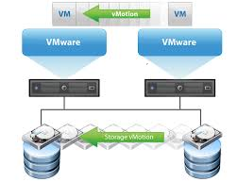

## VCenter Server Components and Services

vCenter Server provides a centralized platform for management, operation, resource provisioning, and performance evaluation of virtual machines and hosts.

When you install vCenter Server with an embedded Platform Services Controller, or deploy the vCenter Server Appliance with an embedded Platform Services Controller, vCenter Server, the vCenter Server components, and the services included in the Platform Services Controller are deployed on the same system.

When you install vCenter Server with an external Platform Services Controller, or deploy the vCenter Server Appliance with an external Platform Services Controller, vCenter Server and the vCenter Server components are deployed on one system, and the services included in the Platform Services Controller are deployed on another system.

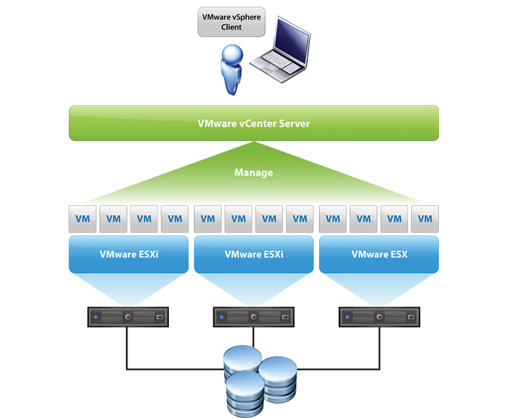

# Proposed solution

* Server virtualization with VMware vSphere
* Software defined storage Atlantis USX

## Server Consolidation

Server consolidation is one of the key benefits of virtualization. It helps alleviate server sprawl and compacts the datacenter. Virtualization using VMware provides several ways to consolidate servers. One of the most basic ideas to consolidation is the ability to share a common resource. In most datacenters today, there is the tendency to over purchase disk space. Disks storage is getting cheaper and larger disks are being installed to provide for growth. Growth that often never reaches the potential of the disk. It’s also been estimated that servers use only 10-15% of their total processor and memory capacity. Given the over purchasing of disk space and the over provisioned machines and the datacenter is left with machines that are underutilized, taking up space and capital. This is where Microsoft’s VMware vSphere provided the ultimate solution for server and datacenter consolidation.

## Software defined storage

**Atlantis Software Defined storage (USX)**

Atlantis USX enables enterprises to pool and abstract all storage (SAN, NAS, Flash, RAM, DAS, Hybrid Arrays, and Public Cloud) and instantly deliver virtual storage volumes to any application. By pooling storage, both storage capacity and performance are used more efficiently in the datacenter, lowering cost, increasing performance and making datacenters more agile.

**Data Services**

Atlantis USX includes integrated HyperDup™ Content-Aware Data Services that leverage Atlantis real-time deduplication technology to provide data reduction, IO acceleration, provisioning, data mobility, security and business continuity for any storage.

**Management**

Atlantis USX provides policy-based management of virtual storage volumes that allows administrators to define the capacity, performance and availability requirement for individual VMs or applications.

**Automation**

Atlantis USX delivers automation of all storage functions through REST APIs that are leveraged by third-party orchestration systems to provide Quality of Service (QoS), self-healing to provide resiliency, autonomics to create the optimal storage volume configurations, and event-based management to automate self-provisioning of applications



## Benefits of Atlantis USX

**Cost Reduction**

Enterprises that deploy Atlantis USX will reduce storage costs by up to 80% by significantly extending the effective capacity of existing storage. This reduces the amount of physical storage required for any application set; avoiding the purchase of additional storage hardware, enabling the deployment of lower cost DAS and public cloud storage, and eliminating the inefficiencies of existing storage hardware.

**Performance**

Atlantis USX delivers all-flash performance across the entire datacenter to all applications, increasing transactions per second for databases, reducing mailbox response time, accelerating virtual desktop performance, and cutting data processing time.

**Data Mobility**

Atlantis USX enables virtual workloads to move between storage systems, datacenters and the cloud in seconds. The new found storage agility opens up new opportunities to move workloads closer to users, lower compute costs, leverage storage in the cloud, or migrate from one storage system to another seamlessly.



## Solution Components

* 3 Super micro physical servers ( 3 server first Site )
* VMware vSphere Essential Plus license
* VMware VCenter
* 10 G Switch
* Windows server 2012 std licenses as per requirement of number of application servers
* Atlantis USX license (Charges per TB of storage)

## VMware Installation

**Project Completion Duration -Within 15 working days (After getting all Hardware& Software)**

All core components for supporting the VMware VSphere Enterprise will be configured, prepared and installed.

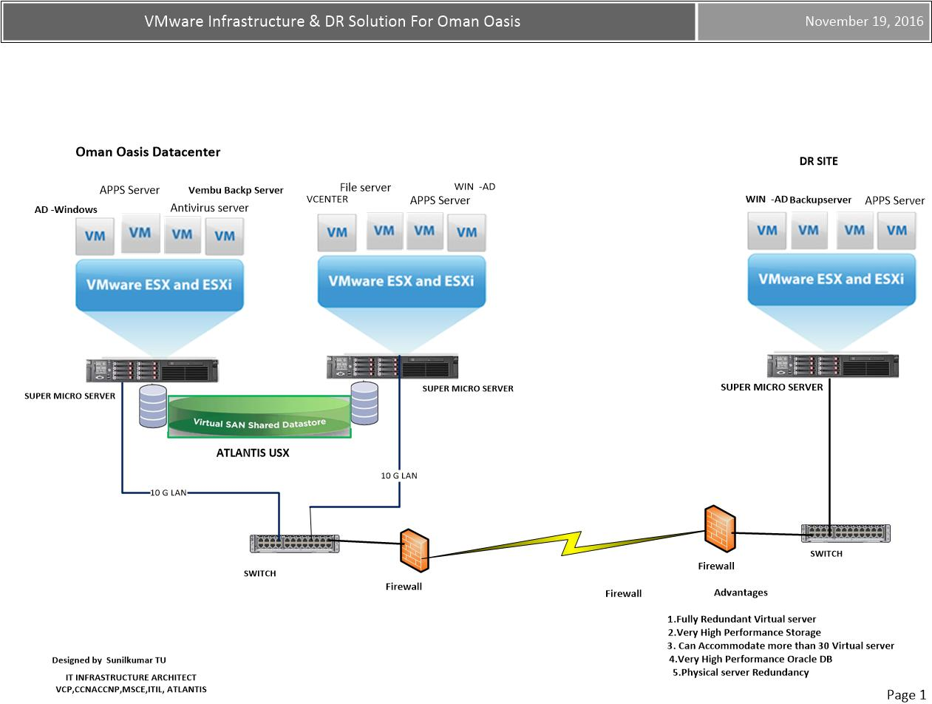

**New Server Installation**

Install VMware ESX on new physical servers

( First site 2 –Super micro server , Second site -1 server)

VCenter Installation

Install Atlantis USX and create common storage pools

**Migration from physical server to virtual server**

Migrate physical server data using vCenter converter to new server

**VLAN and Networking Installation**

Install Switches

Create VLANs

VM Production Network

VM Management Network

VM vMotion Network

Add Subnets to Domain

Add LUNS storage to server environment

**VM server Installation**

Creating Active Directory server/

Additional AD and DNS

Installing File server

Oracle DB, Application server

Vembu Backup

Vembu Disaster recovery

**Virtual Environment Management**

Once the basics are setup and connectivity has been tested, the next steps are to install the management server component. The management server also known as the virtual center is used for all management tasks and is the dashboard for the virtual environment. It too is a simple to follow install.

**ALL THE HARDWARE CONFIGURATION AND STORAGE FOR NEXT 6 YEARS.**

# 

# About Netsolve Systems

NetSolve Systems offers a wide range of IT Infrastructure services, to suit your individual business needs. Our Strategic IT solutions and service standards are Specially designed to help you to achieve a high level of efficiency ,reliability , productivity and security .We bring together advanced technology ,robust infrastructure ,a large pool of talents and proven global delivery standards to provide a wide range of ICT solution and Services to the region , cost –effectively and seamlessly.

**Software defined solutions**

* Data center
* Storage
* Server virtualization
* Desktop Virtualization
* Networking (SDN)
* WAN
* Cloud computing (Private & Public)

**Networking**

* Core networks
* Wireless network
* Network Security ,Security auditing & penetration testing .(black, brown and white)
* IT Infrastructure Monitoring
* VOIP Solutions
* Passive Networks
* Disaster recovery and backup
* Storage (SAN, NAS) and Server
* CCTV, SMS broadcasting

**Software Solution**

* Mobile Apps Development
* Website development & Web Application
* Email Solutions, Access control,
* ERP,CRM& HRMS
* Big Data & Analytics
* Digital Marketing
* Digital Signage.
* Professional services and support
* IT Infrastructure Consulting.

# **BILL OF MATERIAL**

|  |  |  |  |  |
| --- | --- | --- | --- | --- |
| **Sl#** | **Description** | **Qty** | **Unit Price (USD)** | **Total Price (USD)** |
|  |  |  |  |  |
|  | ATLANTIS USX –5 TB Usable Capacity | | | |
| 1 | SuperServer SYS-2028R-C1R  2X Intel Xeon E5-2650 V4 -12 Core  6X32 Gb Memory – 192 GB  2Ports 10GB Card Network Card-1 qty  HGST 2.5" 1.2TB SAS 12 Gb/s 10K RPM 128M  -5 ty  2 x 920W Redundant Power supply | 3 | 9,600.00 | 28,800.00 |
| 2 | SM 512 GB 12 G SATA MU-3 SFF SC SSD-Hot swap | 9 | 750.00 | 1,950.00 |
| 3 | HGST 2.5" 1.2TB SAS 12 Gb/s 10K RPM 128M | 5 | 485.00 | 4,850.00 |
| 4 | Atlantis USX Local Storage Capacity (includes local server DAS, RAM, Flash)-1TB / License (18 TB usable capacity ) | 5 | 1,995.00 | 9,975.00 |
| 5 | Atlantis USX STANDARD Maintenance & Support (includes local server DAS, RAM, Flash) | 5 | 550.00 | 2,750.00 |
| 6 | San storage Installation, configuration  RAID Configuration As per requirement | 1 | 1,500.00 | 1,500.00 |
| 7 | cisco SG550XG-8F8T - switch - 16 ports – L3 -managed (8 x 10GBase-T + 8 x 10 Gigabit SFP+ ) | 1 | 3,450.00 | 3,450.000 |
|  | SOFTWARE LICENSE |  |  |  |
| 8 | VMware VSphere 6 Essential Plus (Max 3 Host) | 1 | 5,100.00 | 5,100.00 |
| 9 | Production Support/Subscription VMware VSphere 5.5 Essentials Plus Kit for -1 YEAR | 1 | 1,450.00 | 1,450.00 |
|  | PROFESSIONAL CHARGES |  |  |  |
| 10 | 1. Super micro Server Mounting-3 2. Installing configuring SWITCH-1 3. VMware Host installation-3 4. VCenter Installation 5. Configuring Networking, 6. Mapping LUN (Storage for VM) 7. Physical Server to virtual 8. Migrating Existing Active directory 9. Installing New Addition Active directory (BDC) 10. Converting Hyper V Vm to VMware VM 11. Existing Microsoft Exchange VM To VMware 12. Configuring Exiting Storage to Software Defined Storage. 13. Migrating Exchange 2013 Mailbox to New DATA STORE (Atlantis ) 14. High Availability Configuring Virtual Machine 15. Configuring DRS 16. Configuring Storage motion 17. Veeam backup server configuration 18. Veeam are Datastore configuring to Existing SAN 19. Testing all the configuring.( Network and VM) 20. Project LIVE.   One Month Basic Training & support for Managing VMware Infrastructure | 1 | 6,500.00 | 6,500.00 |
|  | **Total Amount (USD)** |  |  | **$65,125.00** |

TERMS & CONDITION

* Availability:2-5 weeks from the date of the LPO
* Delivery: ASAP from the date of availability (TBA)
* Confirmation: Formal LPO –Company Letter Head   
   Payment:
* LPO processing: LPO will only be processed on receipt of the 60% advance payment
* 20% On Product Delivery (CDC)
* 20 % CDC on project Completion
* Standard Manufacturer’s Warranty
* This quote is valid 2 weeks.